Edge Criticality Evaluation in Complex Structures and Networks Using an Iterative Edge Betweenness
Zihao Gao¹, Hamza Ejjbiri² and Vasily Lubashevskiy³[0000-0002-2399-5050]
¹ Tokyo International University, 4-42-31 Higashi-Ikebukuro, Toshima, Tokyo, Japan
gzihao2000x@gmail.com
² Tokyo International University, 4-42-31 Higashi-Ikebukuro, Toshima, Tokyo, Japan
ejjbiri.hamza@gmail.com
² Tokyo International University, 4-42-31 Higashi-Ikebukuro, Toshima, Tokyo, Japan
vlubashe@tiu.ac.jp
Abstract. Identifying the edges that played critical roles in understanding the structure and robustness of the network. These key edges facilitate the uninterrupted connection between different network components, and their detection can prevent potential cascading collapses. Various traditional methods that are based on straightforward algorithms can enable us to evaluate the criticality of edges. A widely used method for assessing the importance of these con-nections is the edge betweenness method. This technique measures the criticality of edges by identifying the number of shortest paths passing through a specific edge between any pair of nodes. In our study, we are focused on enhancing the Edge Betweenness method by applying the iterative principle to refine the measurement of edge criticality, which significantly improved the efficiency of network analysis. We applied this improved method to three different benchmark networks: Zachary's Karate Club Network, American Football College Network, and Power Grid Network. The results showed improved efficiency over other state-of-the-art methods, with performance increases of 11.17%, 39.23%, and 90.63% for each network, respectively. These results underline the effectiveness of the Iterative Edge Betweenness method in detecting edges critical to the robustness and stability of complex networks.
Keywords: Complex Networks, Edge Significance, Edge Betweenness.
- Introduction
In the contemporary era, complex networks play an important role in enhancing the functionality of modern society, permeating every facet of daily life. These networks, ranging from communication networks that can provide more efficient means of communication [1] to power supply networks ensuring stable power transmission [2] and transportation [3] systems to facilitating easier travel, have become indispensable for people. In addition to that, complex networks also as-sist scientific analysis, such as protein DNA biological systems [4] for the DNA structures and political networks [1] for research and the spread of ideas. As the complex network gets deeper into various sectors, it is necessary to conduct thorough research on the robustness to guarantee the operation.
Recently, network science has attracted much attention as a multidisciplinary area. With the works of the last decades, it includes a broad range of theories and methods. The patterns of complex networks can be uncovered through the exam-ination from different perspectives, such as the topological structures or the criti-cality value of the links. We can regard them as a basis to enhance the robustness, preventing the network from cascading failures or even collapse. There are multiple directions in the network science. Some researchers are focused on finding the optimization approaches by prediction of new connections in the networks [5], [6], [7], [8]. Some researchers focus on the detection of the resilience of the networks by evaluating the influential nodes [9], [10], [11], [12], [13]. Some researchers are devoted to detecting the critical edges of the network and getting the result of network connectivity after link removal to evaluate the robustness of the network. While past research on network robustness has primari-ly concentrated on node removal, further study into link removal is still neces-sary. This study will addressing this gap by focusing on the removal of edges rather than nodes. This direction is of interest to the present research.
Various methods have been developed to evaluate the criticality of the edges. Most of these methods can be classified into two types of algorithms: straight-forward and integral optimization. Straightforward algorithms are the algorithms that focus on analyzing the features of network topology. They assign specific properties to independent edges and get the criticality values [20]. Straightfor-ward algorithms include the Edge Betweenness [17], the Degree Product [16], the Bridgeness [18], the Diffusion Importance [19], the Topological Overlap [1], the K-path centrality [20], and the Link Entropy [21]. These methods exhibit different performance advantages across network types. For example, in assortative networks, the Degree Product method excels, while in denser networks, the Brid-geness method is more advantageous [21].
In contrast, integral optimization algorithms adopt a holistic perspective rather than the assignment of properties to individual links; these algorithms are in fa-vor of observing the macro-level characteristics. The Evolutionary Approach [22] is a kind of integral optimization algorithm that leverages genetic algorithm principles to evaluate the edge criticality, demonstrating superior efficiency to straightforward algorithms such as improved Link Entropy from the perspective of the final criticality ranking. However, the Evolutionary Approach is much more demanding in terms of computational time and capacity.
Analyzing recent advantages in network science, we have noticed that two new straightforward algorithms have been developed: Deep Link Entropy [14] and Improved Link Entropy [15]. Both of these methods were rooted in Link Entropy and enhanced their efficiency via iterative re-estimation of the topological fea-tures after each edge removal. In this paper, we decided to apply the same princi-ple of step-by-step re-evaluate of the network structure using another criticality approach, the Edge Betweenness [17].
We named the resulting method the iterative edge betweenness, and the result has been compared with the standard edge betweenness, degree product, and Bridg-ness methods. We conducted a numerical simulation of edge criticality ranking and decomposition of three well-known real-life benchmark networks: Zachary's Karate Club [22], American College Football [21], and Power Grid [21]. We will compare the efficiency of the four methods to examine the effectiveness of the Iterative Edge Betweenness method in the following sections.
- Methods
In this section, we will first introduce three methods for network decomposition: the Edge Betweenness, the Degree Product, and the Bridgeness. These methods are used to evaluate the criticality widely in different networks. The Edge Be-tweenness method is the method that we want to improve in this research. For the other two methods, we will use them to compare the decompose efficiency with the Edge Betweenness. The details of the iterative edge betweenness method will also be explained after introducing these three methods.

  - Edge Betweenness
Edge Betweenness is a method that counts the number of shortest paths between one pair of nodes through the specific edge. This algorithm was developed by Linton Freeman, it uses Edge Betweenness centrality to evaluate the criticality of edges [17]. The edge which is frequently evaluated as the shortest path between various pairs of nodes has relatively high criticality because it also means that the edge can connect different parts of the network.

Step 1. For a given undirected graph, $G$ = ($N$, $E$), where $N$ is the set of nodes, and $E$ is the set of edges. For two random nodes $s$, $t$ includes in $N$; we denote $σ_{st}$ as the total number of shortest paths between $N$ and $E$. It reflects the different paths that information or flows in the network.
To find the shortest paths between $N$ and $E$, we will use the Floyd-Warshall algo-rithm. The algorithm will initialize a matrix $X$ based on the distance of the path between one pair of nodes ($s$, $t$); for the nodes without a direct connection, the distance of the path is infinite. The algorithm will select a random node $k$ in the network and try to find a shorter path between $s$ and $t$. If node $k$ can help to find a shorter path, the algorithm will update the shortest path between $i$ and $j$.

Step 2. For the shortest paths between s and t, which go through an edge $E$, we denote it as $σ_{st}(E)$ as the factor to discover the criticality of the edge. The algorithm will evaluate each edge in the network. The $σ_{st}(E)$ reflects the reliability of $E$ for the connection between $N$ and $E$. If $σ_{st}(E)$ has a higher value than the other edges connected between s and t, it also means that edge $E$ has higher criticality.

Step 3. After calculating $σ_{st}$ and $σ_{st}(E)$, we need to know the proportion of the shortest paths between $s$ and $t$, which go through an edge $E$ to all of the shortest paths between $s$ and $t$. If $σ_{st}(E)$ / $σ_{st}$ has a greater value than the other edges, it reflects that the edge plays an important role in maintaining the connection between $s$ and $t$. In other words, $E$ has high criticality.
The formula of this method is the following:
${Betweenness}_{E}$ = $\sum_{s≠t}{\frac{σ_{st}(E)}{σ_{st}}}$ (1)
When the network is fragmented, $σ_{st}$ = 0 when the fragmentation occurs. It is assumed that, in cases where nodes 𝑠 and 𝑡 are discnnected, $\frac{σ_{st}(v)}{σ_{st}}$ is set to zero for the calculation.
  - Degree Product
This is a method utilizing the Degree Product method to describe cascading-failure-induced disasters in weighted networks [16].
${Degree}_{E}$ = $k_{x}k_{y}$ (2)
The degrees of node $x$ and $y$ are denoted by $k_{x}$ and $k_{y}$, respectively. The Degree Product uses the degree of each node, which refers to the number of edges connected to the node. It functions effectively in assortative networks in which nodes are high degree connected [21].
  - Bridgeness
Bridgeness method uses Bridgeness to quantify the significance of edges in sustaining network connectivity [18].
${Bridgeness}_{E}$ = $\frac{\sqrt{S_{x}S_{y}}}{S_{E}}$ (3)
In the Bridgeness method, there are two endpoints x and y, and edge $E$ is included, and the size of a node's or edge's clique E is the largest clique size that includes either the edge or the node. A clique is a subset of a graph in which each pair of nodes is directly connected. This method performs well on dense networks, in which similar or relevant nodes are likely to interconnect such as document and social networks [21].
  - Iterative Edge Betweenness
In normal criticality evaluation, the Edge Betweenness method only evaluates the criticality of edges in the network for once at the beginning, then the edges will be ranked based on their criticality and removed by the sequence. However, with changes in the network topology, the criticality of edges in the current network may also change. Therefore, it is necessary to re-evaluate the criticality after each removal of the edge to suit the current network structure.
As we checked the results from the other researchers, we found examples of “Deep Link Entropy” [14] and “Improved Link Entropy” [15] by applying the iteration principle to improve the efficiency of the Link Entropy method. These methods improved the efficiency of detecting network structures in complex networks by applying the iterative principle. The iterative principle helps these methods to analyze the network structure dynamically, which is crucial to evaluate the criticality of edges accurately. The results of Deep Link Entropy and Improved Link Entropy showed a significant improvement compared to Link Entropy [14] for detecting edge criticality [15]. Based on this discovery, we are going to apply the same iteration principle to the Edge Betweenness method to verify if it can also improve the decomposition efficiency of the Edge Betweenness method.
In our research, we will do the process as Fig. 1 shows.
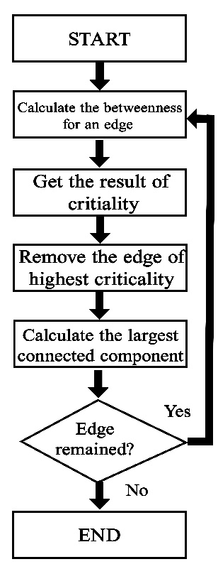
Fig. 1. Flow chart of the whole process for iterative Edge Betweenness.
We will use the Edge Betweenness method to evaluate criticality for all edges at the beginning. Afterward, we will rank them in descending order and select the edge which has the highest criticality. It will be regarded as the most important edge for maintaining connectivity and removing it from the original network. We will calculate $R_{gc}$ and ρ values after this edge’s removal and record them in a list. The data of the new network, which is the network that has already removed the edge from the original network, will be saved in a separate new list. Then, we will execute the above process repetitively until the whole network is completely decomposed.
- Algorithm Performance Measurement
We decompose a complex network by removing the edges. The sequence of edge removal should follow the rank of the criticality of each edge in descending order. The algorithm's decompose efficiency is determined by the size of the largest connected component and the number of removed edges, which is usually denoted as $R_{gc}$ and ρ. It is the value that is obtained by calculating the size of connected components divided by the fraction of the removed edges to all edges. The initial value of $R_{gc}$ is 1 since each node can reach other nodes successfully, and ρ is 0 since there is no edge removed yet.
At first, the evaluation algorithm will traverse all edges in the network and evaluate the criticality of each of them. This process will result in criticality for all edges in a list; thus, we can remove the edges based on rank. Secondly, we will remove the edge that has the highest criticality on the list. When the network decomposes completely, the value ρ will become 1, and $R_{gc}$ will become 0, eventually. The reason for using $R_{gc}(ρ)$ criteria is attributed to its intelligibility. The highest criticality edge has the greatest impact on network connectivity; removal of the edges may affect the communication efficiency of the network. The greater the criticality of the removed edges, the more abruptly the value of $R_{gc}$ decreases as $ρ$ grows, which also reflects the decomposition efficiency.
Based on the $R_{gc}$ (ρ) criteria, we applied the $S_{rgc}$ value as the accurate measurement of the decomposition efficiency. Intuitively speaking, $S_{rgc}$ is the value that calculates the area under the curve $R_{gc}$ (ρ). This criterion emphasizes the general features of network topology instead of the specific aspects of the network's structure at the micro-level [21]. The network decomposition is denoted as a sequence of discrete values {$ρ_{i}$}(i$∈$[0, $m$])with the spacing 1/$m$. The formula of the $S_{rgc}$ is shown in the following:
$S_{rgc}$ = $\frac{1}{m}\sum_{i=0}^{m}{R_{gc}(ρ_{i})}$ (4)
The $S_{rgc}$ represents a distinct approximation of the theoretical continuous integral of $R_{gc}$ (ρ) across the interval from 0 to 1 [21]. We acknowledge that the network decomposition is more efficient while the $S_{rgc}$ value is smaller. The $S_{rgc}$ value of different methods will be shown in the discussion part of the paper to compare the decomposition efficiency more accurately.
- Data and Numerical modeling
To show the performance among the original methods such as Edge Betweenness, Degree Product, and Bridgeness and iterative Edge Betweenness, we will use three popular benchmark networks, Zachary's Karate Club Network, American Football Network, and Power Grid Network with $R_{gc}$ (ρ) criteria to do the numerical modeling for these four methods. To show the structural properties of these benchmark networks, we listed the basic statistical data in Table 1.
Table 1. Basic statistics of three benchmark networks. Structural properties include the number of nodes (N), the number of edges (E), the average degree (<k>), the maximum degree(k_max), the degree heterogeneity (H_k), and the clustering coefficient (C).
Networks | N | E | <k> | $$k_{max}$$ | $$H_{k}$$ | C
Karate | 34 | 78 | 4.5882 | 17 | 1.6933 | 0.5706
Football | 115 | 613 | 10.6609 | 12 | 1.0069 | 0.4032
Power | 4941 | 6594 | 2.6691 | 19 | 1.4504 | 0.0801

Zachary's Karate Club Network
This network is often used in testing various methods of network analysis. It is the network of friendships that binds the 34 karate club members at a US university together, comprising 78 edges and 34 nodes, which represents a small size network. We will show the circular layout of Zachary's Karate Club Network in Fig. 1.
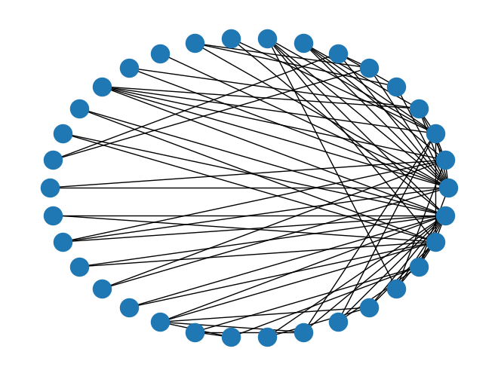
Fig. 2. This figure presents Zachary's Karate Club network in a circular layout. This network has relatively low density, indicating that not every node interacts with the other nodes.
In Fig. 3, we will compare Zachary's Karate Club Network's decomposition. $R_{gc}$ (ρ) curves of Edge betweenness, Iterative Edge Betweenness, Degree Product, and Bridgeness are shown in the graph.
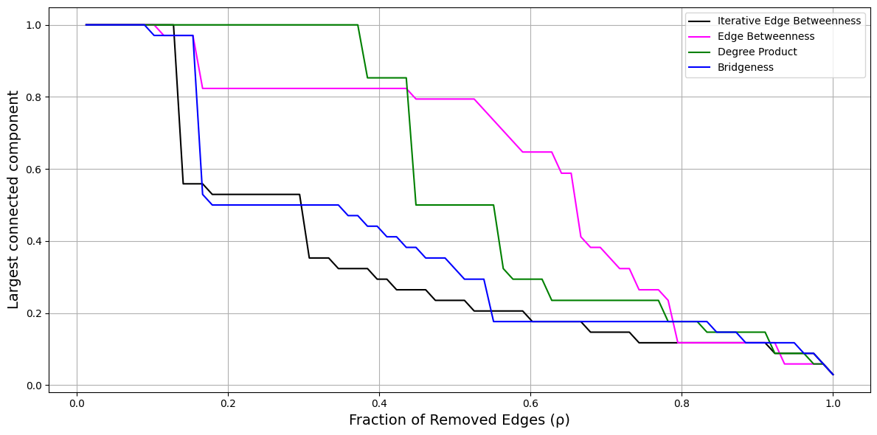
Fig. 3. This figure draws a graph along with Zachary's Karate Club Network’s decomposition as determined by four methods: the Edge Betweenness (pink line), the Degree Product (green line), the Bridgeness (blue line), and Iterative Edge Betweenness (black line). The graph shows how the proportion of nodes ρin the largest connected component of $R_{gc}$ changes as we remove edges.
According to the graph, compared to the curve of Edge Betweenness, the curve of iterative Edge Betweenness has a more significant drop, which also indicates that it has better efficiency. However, the curves of Iterative Edge Betweenness and Bridgeness are similar. It is hard to figure out which one is better. To compare the efficiency accurately, we will calculate the $S_{rgc}$ value for Zachary's Karate Club Network’s decomposition in the discussion part. In a small-size network, the iterative Edge Betweenness may not outperform well than the other three methods. In the next part, we will use the American College Football Network, a medium-sized network for decomposition with these four methods.

American College Football Network
This is a network of American College Football games among Division IA colleg-es. The data of this network was collected from the standard season in 2000’s autumn. It can be considered an exemplar of medium-scale networks, comprising 115 nodes and 613 edges. The circular layout of the American College Football Network will be shown in Fig. 4.
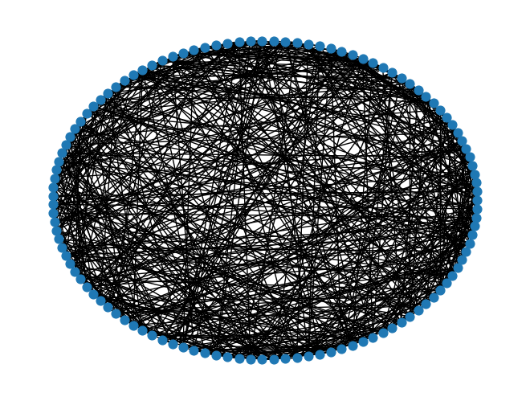
Fig. 4. This figure presents the American College Football network in a circular layout. This network has lots of connections.
In Fig. 5, we will decompose the American College Football network and compare the $R_{gc}$ (ρ) curves of Edge Betweenness, Iterative Edge Betweenness, Degree Product, and Bridgeness.
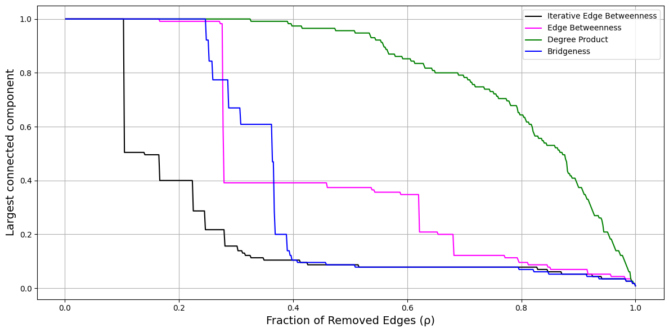
Fig. 5. This figure draws a graph along with American College Football’s decomposition as determined by four methods: the Edge Betweenness (pink line), the Degree Product (green line), the Bridgeness (blue line), and Iterative Edge Betweenness (black line). The graph shows how the proportion of nodes ρin the largest connected component of R_gc changes as we remove edges.
We can see that the Iterative Edge Betweenness method has dropped at the earliest time among these four methods. It shows that the Iterative Edge Betweenness method not only outperforms the decomposition efficiency of the Edge Betweenness method but is also better than the Degree Product and Bridgeness methods. To compare the efficiency accurately, we will calculate the $S_{rgc}$ value for American College Football’s decomposition in the discussion part. From the result of this decomposition, we can see that the Iterative Edge Betweenness has more obvious efficiency advantages in medium-size networks. In addition to the above two benchmark networks, we also want to do network decomposition with these methods on networks with large sizes.

Power Grid Network
Power Grid Network as an undirected, unweighted representation of the topology of the Western States Power Grid of the United States. This network consists of 4941 nodes and 6594 edges, whose size is larger than Zachary's Karate Club Network and American College Football Network. This network was used as one of the benchmark networks with unique characteristics to compare the performance of different methods. This is a network that considers the flow and distribution of resources. We will show the circular layout of the Power Grid Network in Fig. 6.
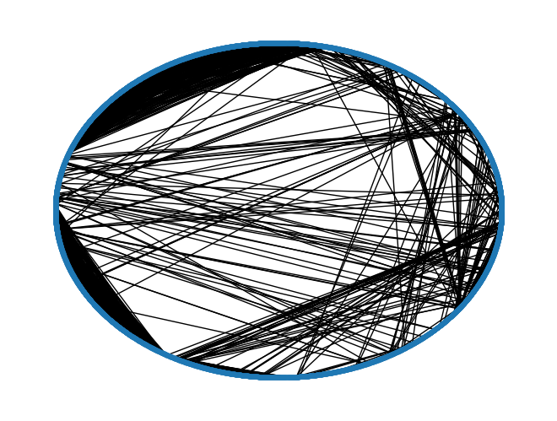
Fig. 6. This figure presents the Power Grid Network in a circular layout. Some edges in this network are close to each other, which reflects that this network has more obvious clustering than the other networks.
In Fig. 7, we will decompose the Power Grid Network and compare the $R_{gc}$ (ρ) curves of Edge betweenness, Iterative Edge Betweenness, Degree Product, and Bridgeness.
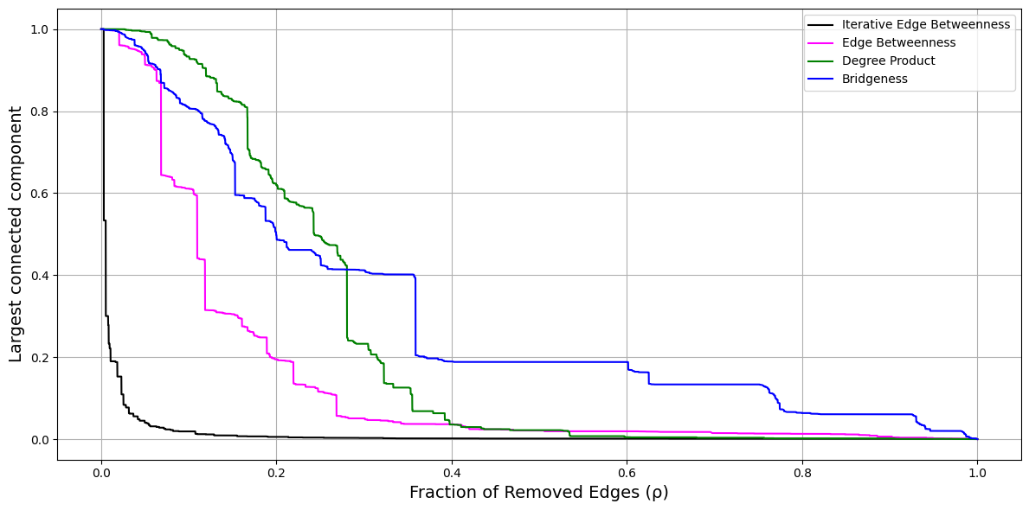
Fig. 7. This figure draws a graph along with the Power Grid network’s decomposition as determined by four methods: the Edge Betweenness (pink line), the Degree Product (green line), the Bridgeness (blue line), and Iterative Edge Betweenness (black line). The graph shows how the proportion of nodes ρin the largest connected component of R_gc changes as we remove edges.
According to the graph of the Power Grid Network’s decomposition, the curve of the Iterative Edge Betweenness method has dropped dramatically at the beginning, and the largest connected component value goes down to 0 rapidly, which means that the efficiency is much better than the other three methods. To make this a little bit more intuitive, we will calculate the $S_{rgc}$ value for the Power Grid Network’s decomposition in the discussion part. From the result of this decomposition, we can see that the advantage of the efficiency of Iterative Edge Betweenness has become more significant in large-size networks.
- Discussion
We have decomposed three benchmark networks of different scales of nodes and edges with Zachary’s Karate Club network, the American College Football network, and the Power Grid network. The results are shown in Fig. 3, Fig. 5, and Fig. 7. These figures show the impact of removing edges on the size of the largest connected component in $R_{gc}$ for the Edge Betweenness, Degree Product, Bridgeness, and Iterative Edge Betweenness which are used in network decomposition.
Through the research, we have found that the Iterative Edge Betweenness method outperforms the other methods. The $R_{gc}$ curve of decomposition efficiency of iterative Edge Betweenness has performed a more pronounced drop. To compare the efficiency accurately among different methods, we will calculate $S_{rgc}$ for the decomposition of each benchmark network with these methods. The data of $S_{rgc}$ values will be shown in Table 2.
Table 2. This table presents the $S_{rgc}$ of three benchmark networks. These values enable us to compare the decomposition efficiency among different methods.
Methods | $S_{rgc}$ in the Karate network | $S_{rgc}$ in Football network | $S_{rgc}$ in Power network
Iterative Edge Betweenness | 0.34766 | 0.22829 | 0.01326
Edge Betweenness | 0.60294 | 0.44442 | 0.14153
Degree Product | 0.56825 | 0.81237 | 0.24180
Bridgeness | 0.39140 | 0.37567 | 0.30766
According to the table, the lower $S_{rgc}$ of iterative Edge Betweenness reflects that it has better efficiency of network decomposition in three benchmark networks with different sizes and structures. It is not only better than the Edge Betweenness method, but also better than the Degree Product method, and Bridgeness method.
We selected the method that has the lowest $S_{rgc}$ value other than Iterative Edge Betweenness in each benchmark network and used it to show the percentage of efficiency increment of the Iterative Edge Betweenness method. In Zachary's Karate Club, Bridgeness has the $S_{rgc}$ value 0.39140, which has the best efficiency other than the Iterative Edge Betweenness method. With the $S_{rgc}$ value 0.34766, the Iterative Edge Betweenness method exceeds Bridgeness’s $S_{rgc}$ value in 11.17%. In the American College Football Network, Bridgeness has the $S_{rgc}$ value 0.37567, which has the best efficiency other than the Iterative Edge Betweenness method. The Iterative Edge Betweenness method exceeds Bridgeness’s $S_{rgc}$ value by 39.23%. In the Power Grid network, Edge Betweenness has the $S_{rgc}$ value 0.14153, which has the best efficiency other than the Iterative Edge Betweenness method. The Iterative Edge Betweenness method exceeds the Edge Betweenness’s $S_{rgc}$ value by 90.63%. With these values, we can assume that as the network’s size increases, the superiority of the Iterative Edge Betweenness method also becomes more significant. It should come from the fact that the more complex and big the network – the harder it is to define the best decomposition sequence from the initial topological metrics. Correspondingly, the iterative reassessment of those features should provide a much better result. However, this assumption verification might be the purpose of the next research.
The Iterative Edge Betweenness method exhibits significant limitations, particularly in terms of running times. Compared to the other traditional method, Iterative Edge Betweenness needs much time to identify the criticality of all edges in the network since it recalculates the shortest paths between every pair of nodes for each edge within the network. In addition to this, since the Iterative Edge Betweenness method needs to be run after each edge removal, it needs much more time than the Edge Betweenness method. Consequently, as network size increases, so does computational time. Therefore, for a time-sensitive decomposition task, this method may not be the optimal choice.
- Conclusion
The study of edge criticality in complex networks is an essential pillar of network science. A variety of methods have been developed to address this issue more efficiently across networks of different sizes and types. Our research has been innovated by adopting an iterative approach applied to the Edge Betweenness method to evaluate the edge criticality, which can help evaluate the robustness of the network.
The iterative principle has already been shown to be feasible by applying it to the edge betweenness method. It demonstrated superior efficiency by significantly improving network decomposition compared to traditional methods such as Edge Betweenness, Degree Product, and Bridgeness. Notably, it succeeded in obtaining lower $S_{rgc}$ values, proving its potential for optimizing network analysis performance. Through numerical tests carried out on various networks such as the Zachary's Karate Club Network, the American College Football Network, and the Power Grid Network, we confirmed that the iterative Edge Betweenness approach offers superior results in terms of critical edge identification, outperforming traditional methods.
Our research aims not to undermine the effectiveness of traditional methods but to highlight that the iterative principle could provide additional benefits to traditional methods in specific networks. Indeed, this research enriches the existing corpus by demonstrating that methodological innovation can bring substantial benefits to the assessment of network robustness. We hope our findings will inspire other researchers to explore new methods for improving network analysis and to consider new research directions in this dynamic field.
In conclusion, our study not only offers an alternative method for evaluating edge criticality in complex networks but also opens up an enriching dialogue on the practical application of these techniques for the design and optimization of networks in the face of future challenges. It lays a solid foundation for future explorations in network science, underlining the importance of continuing to diversify and refine evaluation tools to understand better and manage the complexity of our world's interconnected systems.
Acknowledgments. This study was partially funded by the Personal Research Fund of Tokyo International University.
Disclosure of Interests. The authors have no competing interests to declare that are relevant to the content of this article.

References
- Onnela, J.-P., Saramäki, J., Hyvönen, J., Szabó, G., Lazer, D., Kaski, K., Kertész, J., Barabási, A.-L.: Structure and tie strengths in mobile communication networks. Proceedings of the National Academy of Sciences 104(18), pp. 7332–7336 (2007)
- Wang, Z., He, J., Nechifor, A., Zhang, D., Crossley, G.: Identification of critical transmission lines in complex power networks. Energies 10(9), 1294 (2017)
- Ghosh, S., Banerjee, A., Sharma, N., Agarwal, S., Ganguly, N.: Statistical analysis of the Indian railway network: A complex network approach. Acta Physica Polonica B Proceedings Supplement 12(2), p. 123 (2011)
- Sathyapriya, R., Vijayabaskar, M. S., Vishveshwara, S.: Insights into protein–DNA interactions through structure network analysis. PLoS Comput. Biol 4(9), Art. no. e1000170 (2008)
- Ma, X., Sun, P., Wang, Y.: Graph regularized nonnegative matrix factorization for temporal link prediction in dynamic networks. Physica A: Statistical Mechanics and its Applications 496, 121–136 (2018)
- Jamali, A. A.,Kusalik, A., Wu. F.X.: NMTF–DTI: A nonnegative matrix tri factorization approach with multiple kernel fusion for drug target interaction prediction,’’ IEEE/ACM Transactions on Computational Biology and Bioinformatics 20(1), 586–594 (2023)
- Tofighy, S., Charkari, N. M., Ghaderi, F.: Link prediction in multiplex networks using intralayer probabilistic distance and interlayer co-evolving factors. Physica A: Statistical Mechanics and its Applications 606, Art. no. 128043 (2022)
- Yin, Y., Wu, Y., Yang, X., Zhang, W., & Yuan, X.: SE–GRU: Structure embedded gated recurrent unit neural networks for temporal link prediction. IEEE Transactions on Network Science and Engineering 9(4), 2495–2509 (2022)
- Lv, J., Yang, B., Yang, Z., Zhang, W.: A community-based algorithm for influence blocking maximization in social networks. Cluster Computing 22, 5587–5602 (2017)
- Salavati, C., Abdollahpouri, A., Manbari, Z.: Ranking nodes in complex networks based on local structure and improving closeness centrality. Neurocomputing 336, 36–45 (2019)
- Dai, Z., Li, P., Chen, Y., Zhang, K., Zhang, J.: Influential node ranking via randomized spanning trees. Physica A: Statistical Mechanics and its Applications 526, Art. no. 120625 (2019)
- Zhao, G., Jia, P., Zhou, A., Zhang, B.: InfGCN: Identifying influential nodes in complex networks with graph convolutional networks. Neurocomputing 414, 18–26 (2020)
- Yang, H., An, S.: Critical nodes identification in complex networks. Symmetry 12(1), 123 (2020)
- Ozaydin, S. Y., & Ozaydin, F.: Deep link entropy for quantifying edge significance in social networks. Applied Sciences 11(23), Art. no. 11182 (2021)
- Lubashevskiy, V., Ozaydin, S. Y., & Ozaydin, F.: Improved link entropy with dynamic community number detection for quantifying significance of edges in complex social networks. Entropy 25(2), 365 (2023)
- Wang, W., & Chen, G.: Universal robustness characteristic of weighted networks against cascading failure. Physical Review E 77(2), Art. no. 026101 (2008)
- Girvan, M., Newman, M. E. J.: Community structure in social and biological networks. Proceedings of the National Academy of Sciences 99(12), pp. 7821–7826 (2002)
- Cheng, X., Ren, F., Shen, H., Zhang, Z., & Zhou, T.: Bridgeness: A Local Index on Edge Significance in Maintaining Global Connectivity. Journal of Statistical Mechanics: Theory and Experiment 10, Art. no. P10011 (2010)
- Liu, Y., Tang, M., Zhou, T., Do, Y.: Improving the accuracy of the k-shell method by removing redundant links from a perspective of spreading dynamics. Scientific Reports 5, 13172 (2015)
- De Meo, P., Ferrara, E., Fiumara, G., Ricciardello, A.: A novel measure of edge centrality in social networks. Knowledge-Based Systems 30, 136–150 (2012)
- Qian, Y., Li, Y., Zhang, M., Ma, G., & Lu, F.: Quantifying edge significance on maintaining global connectivity. Scientific Reports 7(1), Art. no. 45380 (2017)
- Lubashevskiy, V., Lubashevsky, I.: Evolutionary Approach for Detecting Significant Edges in Social and Communication Networks. IEEE Access 11, 58046-58054 (2023)

